Sem 2 week 4 OOP Rory O Loughlin g00422319 databases

1. Return all actors whose last names are ALLEN from the actor table:

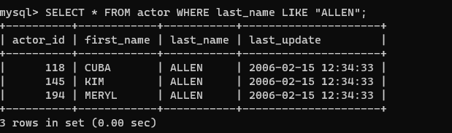

2. Return all the actors who’s last_name column has a value DAVIS, and the row’s first_name has a value SUSAN: 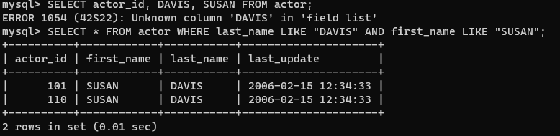

3. Return all actors where last_name column has a value ALLEN or DAVIS

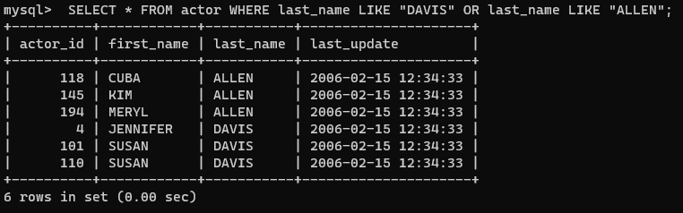

4. Return the number of categories which have a name that does not start with the letter A.

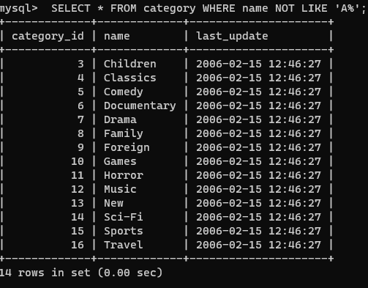

5. Return all actor names and the name of each film title they were in.

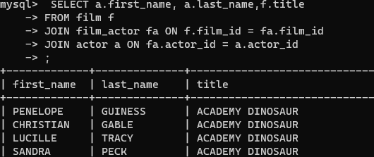

6. Return the title, release year, and category of all movies.

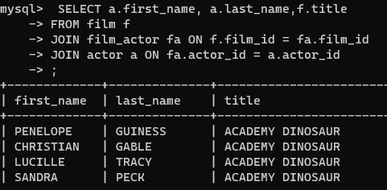

7. Return how much JOHNNY TURPIN has spent on movie rentals

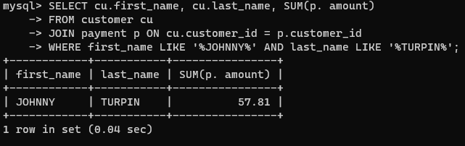

8. Return the name of the customer that has spent the most of movie rentals, include the amount they have spent.

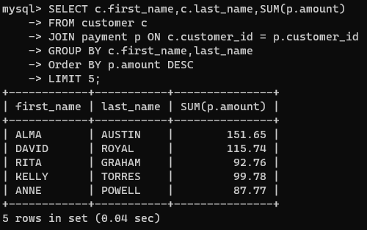

9. Return all movie title, release year, actor name and category where the actor first_name is ‘Sean’